Batch-52

Your text here

Md Shafiqul Islam Agro

One of The Bangladeshi Agro Brand

**Rabby Agro**

hhhhjhgdfg

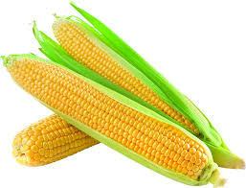

Md Rabby Hossen

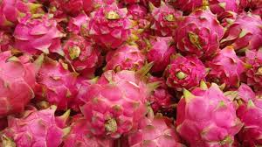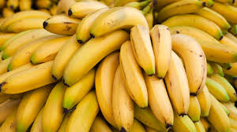

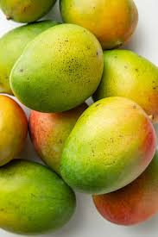

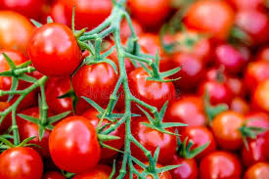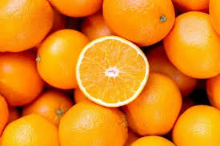

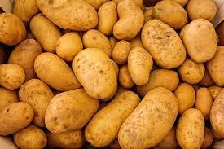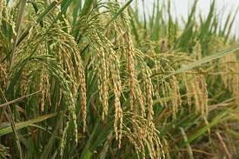

Table of Contents

**Summary :** 3

**1****Introduction** 4

**2****Majore Products of Agro** 4

**2.1****Rice** 4

**2.2****Wheat** 5

**2.3****Tomato** 5

**2.4****Potato** 6

**2.5****vegetables** 6

**2.6****Seasonal Production** 7

Summer Vegetables 7

Winter Vegetables 7

**2.7****Fruits** 7

**3****Service to customer** 9

**3.1****High-Quality Produce** 9

**3.2****Customer-Centric Approach** 9

**3.3****Educational Outreach** 9

**3.4****Sustainability and Environmental Responsibility** 10

**3.5****Customer Support** 10

**4****Agro Farm’s business plan** 11

**5****Contributions to Local Demand** 12

**5.1****Crops Production Tabel &Chart** 12

**Conclusion** 13

**Rabby Agro**

# **Summary:**

Agriculture is the art and science of cultivating the soil, growing crops, and raising livestock. It encompasses everything from planting seeds to harvesting, and from caring for animals to processing their products. These products, as well as the agricultural methods used, may vary from one part of the world to another. Agriculture encompasses crop and livestock production, aquaculture, and forestry for food and non-food products. Agriculture was a key factor in the rise of sedentary human civilization, whereby farming of domesticated species created food surpluses that enabled people to live in cities.

we understand that we have a corporate responsibility to the consumers of our products and the farmers we work with; to help foster good health and promote healthier food choices through access to safe and affordable nutrition. We are a responsible organization, providing trusted sustainable farm-based solutions and healthy food choices to help consumers make informed decisions. We aim to deliver a nourishing food and farm-based service through our brands while committing to a safe environment. Sustainable production of sufficient high-quality food for a growing population is a major global challenge; there is also a growing need for a more stable and balanced ecosystem while engaging the environment to provide man’s basic needs. This involves the need to conserve biodiversity and manage natural resources; improve human health and well-being, especially for the rural poor in developing countries.

As such, we engage sustainable farming methods to further increase the productivity of existing farmland through good and efficient management practices, while embracing the three pillars of sustainability.

Creating a range of products and services for “Shafiq Agro Farm” in Bangladesh can help you cater to diverse market needs and ensure a sustainable business. Here are some ideas.

# **Introduction**

**Rabby Agro Farm** is a prominent agricultural enterprise located in Barisāl, Bangladesh. Specializing in the cultivation of essential crops such as rice, potatoes, wheat, vegetables, and fruits, the farm plays a crucial role in meeting the local demand for these staples. By ensuring a steady supply of high-quality produce, Rabby Agro Farm not only supports the dietary needs of the local population but also contributes significantly to the economic stability and growth of the region.

The farm’s operations are designed to maximize productivity while adhering to sustainable farming practices. This approach not only enhances the farm’s output but also ensures the long-term health of the soil and surrounding environment. Through its commitment to quality and sustainability, Rabby Agro Farm has established itself as a key player in the local agricultural sector, fostering food security and economic resilience in Barisāl and beyond.

# **Majore Products of Agro**

## **Rice**

Rice is a staple food for a large part of the world’s population. It is grown in flooded fields called paddies. The System of Rice Intensification (SRI) is a sustainable method that uses fewer seedlings and less water, improving yield and soil health. Bangladesh is the third-largest producer of rice globally, with a production volume of about 39.1 million tonnes in 2023.

Producing 3,500 metric tons (MT) of rice annually at Rabby Agro Farm is indeed a significant achievement and beneficial for Bangladesh. Contribution of Rabby Agro Farm Producing 3,500 MT of rice annually contributes significantly to the local food supply, supporting the community and local markets.

Implementing sustainable farming practices can enhance soil health and yield, ensuring long-term productivity.

## **Wheat**

Wheat is a major cereal crop used to produce flour for bread, pasta, and other food products. It is grown in temperate regions and requires well-drained soil and moderate temperatures. Producing 2,500 metric tons (MT) of wheat annually at Rabby Agro Farm is indeed a significant achievement and beneficial for Bangladesh. Wheat farming contributes to the national economy by providing employment and income for farmers and those involved in the supply chain. High wheat production helps ensure food security, reducing the need for imports and stabilizing local food prices. Bangladesh produces about 1.1 million tonnes of wheat annually3. The contribution from Rabby Agro Farm represents a substantial portion of this total.

## **Tomato**

Tomatoes are versatile fruits used in a variety of culinary dishes. They require warm weather, plenty of sunlight, and well-drained soil. Tomatoes can be grown in open fields or greenhouses. Producing 1,800 MT of tomatoes annually contributes significantly to the local food supply, supporting the community and local markets. Implementing sustainable farming practices can enhance soil health and yield, ensuring long-term productivity. The farm’s production supports local employment and can stimulate economic activities in the region.

National Production: Bangladesh produced approximately 442,000 tonnes of tomatoes in 2023. The contribution from Rabby Agro Farm represents a substantial portion of this total. Tomatoes are typically grown during the winter season in Bangladesh, but heat-tolerant varieties can also be grown in summer with specialized crop management practices.

## **Potato**

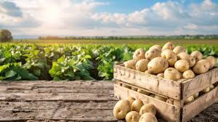Potatoes are tuber crops that thrive in cool climates with well-drained, fertile soil. They are a significant source of carbohydrates and are used in many dishes worldwide. Producing 2,800 metric tons (MT) of potatoes annually at Rabby Agro Farm is indeed a significant achievement and beneficial for Bangladesh. Potatoes are a major source of carbohydrates, vitamins, and minerals, making them an essential part of the diet for many people.

Potato farming contributes significantly to the national economy by providing employment and income for farmers and those involved in the supply chain. High potato production helps ensure food security, reducing the need for imports and stabilizing local food prices. Producing 2,800 MT of potatoes annually contributes significantly to the local food supply, supporting the community and local markets. Implementing sustainable farming practices can enhance soil health and yield, ensuring long-term productivity. The farm’s production supports local employment and can stimulate economic activities in the region.

Bangladesh produced more than 11 million tonnes of potatoes in 2023, making it the third-largest producer in Asia. The contribution from Rabby Agro Farm represents a substantial portion of this total. Potatoes are typically grown during the winter season in Bangladesh, requiring cool temperatures and well-drained soil.

## **vegetables**

Producing a variety of summer and winter vegetables annually at Rabby Agro Farm is highly beneficial for Bangladesh. Importance of Year-Round Vegetable Production .Vegetables are rich in essential vitamins, minerals, and fiber, which are crucial for a balanced diet and overall health. Vegetable farming contributes significantly to the national economy by providing employment and income for farmers and those involved in the supply chain. High vegetable production helps ensure food security, reducing the need for imports and stabilizing local food prices.

Producing a variety of vegetables throughout the year ensures a steady supply to local markets, supporting the community and local retailers. This helps meet the local demand for fresh produce, which is essential for maintaining a healthy diet.

Implementing sustainable farming practices can enhance soil health and yield, ensuring long-term productivity. The farm’s production supports local employment and can stimulate economic activities in the region.

****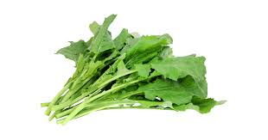

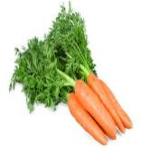

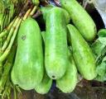

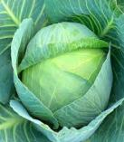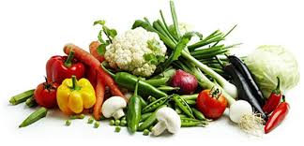

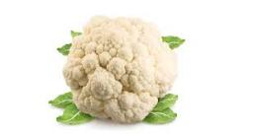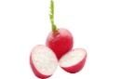

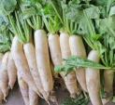

## **Seasonal Production**

Summer Vegetables: Includes crops like tomatoes, cucumbers, and eggplants, which thrive in warmer temperatures. These vegetables are crucial during the summer months when the supply of fresh produce can be limited.

Winter Vegetables: Includes crops like potatoes, carrots, and cabbages, which grow well in cooler temperatures. These vegetables are essential during the winter months when they are in high demand. Enhancing Productivity to further enhance productivity and sustainability, Rabby Agro Farm could consider using high-yielding vegetable varieties can increase production.

Implementing water-saving techniques and proper irrigation can improve water use efficiency. Reducing reliance on chemical pesticides through integrated pest management practices can improve environmental sustainability. Overall, the farm’s contribution is a positive step towards supporting the agricultural sector and ensuring food security in Bangladesh.

## **Fruits**

Producing a variety of fruits such as oranges, bananas, guavas, watermelons, papayas, and mangoes annually at Rabby Agro Farm is highly beneficial for Bangladesh. Nutritional Value: Fruits are rich in essential vitamins, minerals, and antioxidants, which are crucial for a balanced diet and overall health. Fruit farming contributes significantly to the national economy by providing employment and income for farmers and those involved in the supply chain. High fruit production helps ensure food security, reducing the need for imports and stabilizing local food prices.

Contribution of Rabby Agro Farm Producing a variety of fruits throughout the year ensures a steady supply to local markets, supporting the community and local retailers. This helps meet the local demand for fresh produce, which is essential for maintaining a healthy diet. Implementing sustainable farming practices can enhance soil health and yield, ensuring long-term productivity. The farm’s production supports local employment and can stimulate economic activities in the region.

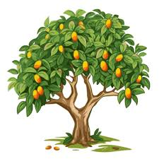****

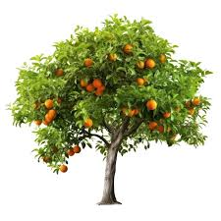



WOW

**Oranges**: Rich in vitamin C, oranges boost the immune system and are popular both fresh and as juice. Oranges are citrus fruits rich in vitamin C. They grow best in subtropical and tropical climates with well-drained soil and plenty of sunlight. Oranges are consumed fresh or processed into juice.

Each of these crops has specific requirements for soil, water, and climate, making it important to choose the right methods and conditions for cultivation to ensure a successful harvest.

**Bananas**: High in potassium, bananas are great for heart health and are a staple fruit in many households.

**Guavas:** Packed with vitamin C and dietary fiber, guavas are excellent for digestion and overall health.

**Watermelons**: Hydrating and refreshing, watermelons are perfect for hot climates and are rich in vitamins A and C.

**Papayas:** Rich in vitamins A and C, papayas aid digestion and boost the immune system.

**Mangoes:** Known as the “king of fruits,” mangoes are rich in vitamins A and C and are enjoyed fresh or in various dishes.

To further enhance productivity and sustainability, Rabby Agro Farm could consider using high-yielding fruit varieties can increase production. Implementing water-saving techniques and proper irrigation can improve water use efficiency. Reducing reliance on chemical pesticides through integrated pest management practices can improve environmental sustainability.

Overall, the farm’s contribution is a positive step towards supporting the agricultural sector and ensuring food security in Bangladesh.

# **Service to customer**

Rabby Agro Farm is dedicated to providing exceptional service to its customers by ensuring the highest quality of produce and a seamless buying experience. Here’s how they serve their customers:

## **High-Quality Produce**

* Freshness Guaranteed: All produce, including rice, wheat, potatoes, tomatoes, vegetables, and fruits, is harvested at peak ripeness to ensure maximum freshness and flavor.
* Organic Options: The farm offers a variety of organically grown vegetables and fruits, catering to health-conscious customers.

## **Customer-Centric Approach**

* Direct Sales: Customers can purchase produce directly from the farm, ensuring they receive the freshest products possible.
* Farm Stands and Markets: The farm regularly participates in local markets and operates farm stands, making it convenient for customers to buy fresh produce.
* Online Orders: For added convenience, customers can place orders online and have their produce delivered to their doorstep.

## **Educational Outreach**

* Farm Tours: The farm offers guided tours to educate customers about sustainable farming practices and the journey of their food from farm to table.
* Workshops and Events: Regular workshops and events are held to teach customers about organic farming, gardening, and healthy eating.

## **Sustainability and Environmental Responsibility**

* Eco-Friendly Practices: The farm uses sustainable farming methods, including renewable energy sources and effective waste management, to minimize environmental impact.
* Community Support: By supporting local markets and reducing the carbon footprint associated with long-distance transportation, the farm contributes to the local economy and promotes environmental sustainability.

## **Customer Support**

* Responsive Service: The farm’s customer service team is always ready to assist with inquiries, orders, and any issues that may arise.
* Feedback and Improvement: Customer feedback is highly valued and used to continuously improve the quality of products and services.

Rabby Agro Farm is committed to delivering the best possible experience to its customers, ensuring they receive fresh, high-quality produce while supporting sustainable and environmentally friendly practices.

**We can create a pie chart to show the distribution of different crops produced by Rabby Agro Farm:**

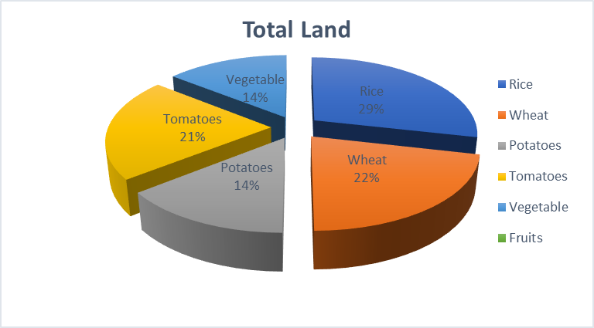

# **Agro Farm’s business plan**

Executive Summary

Market Analysis

Wheat Production

Rice Production

Production Plan

Fruit Production

Potato Production

Revenue Streams

Cost Management

Financial Projections

Job Creation

Market Stability

Economic Impact

Community Engagement

Sustainability Initiatives

Environmental Stewardship

END

# **Contributions to Local Demand**

Rabby Agro Farm plays a significant role in meeting the local demand for various agricultural products in Barisāl, Bangladesh. By producing essential crops like rice, wheat, tomatoes, potatoes, and a variety of fruits, the farm helps to ensure a steady supply of these staples to the local markets. This not only supports the local economy but also contributes to food security in the region.

## **Crops Production Tabel &Chart**



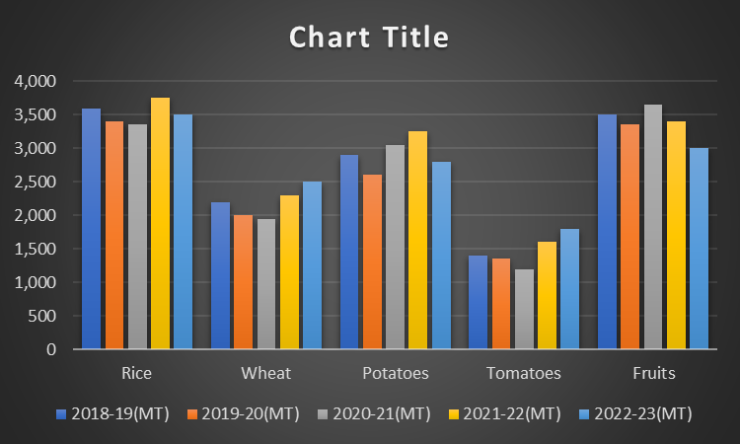

# **Conclusion**

Rabby Agro Farm significantly contributes to the local economy and food security in Barisāl, Bangladesh, by producing a variety of essential crops. Here's a detailed look at its contributions As staple foods in Bangladesh, the production of rice and wheat by Rabby Agro Farm helps to meet the daily dietary needs of the local population. This reduces dependency on imports and stabilizes local food prices. These are crucial for a balanced diet, providing essential nutrients. The farm's production ensures a steady supply of fresh produce, enhancing the nutritional intake of the community.

By growing a variety of fruits, the farm adds diversity to the local diet and supports overall health and well-being. The farm provides employment opportunities for local residents, contributing to the reduction of unemployment and boosting the local economy. By supplying local markets with a consistent flow of agricultural products, the farm helps stabilize prices and ensures that local businesses have reliable access to fresh produce. Implementing sustainable farming practices can lead to long-term benefits for the environment and the economy, promoting a healthier ecosystem and reducing costs associated with environmental degradation. The farm's production capacity helps ensure that the local community has access to sufficient food, reducing the risk of food shortages. By contributing to the local supply chain, the farm supports other businesses, such as transportation and retail, fostering overall economic growth in the region.

**Similar Agro Farm**

* [Farming Future Bangladesh (FFB)](https://www.f6s.com/company/farming-future-bangladesh-ffb)
* [Amir Agro Farm](https://www.tbsnews.net/interviews/sea-opportunity-handicraft-business-128149)
* [Organic Farming](https://www.f6s.com/companies/organic-farming/mo)
* [Farmshelf](https://www.f6s.com/company/farmshelf)
* [Babylon Micro-Farms Inc](https://www.f6s.com/company/babylonmicro-farmsinc)
* [Clean Crop Technologies](https://www.f6s.com/company/cleancroptechnologies)
* [Tortuga AgTech](https://www.f6s.com/company/tortugaagtech)